**Resume of**

**NOOREN ZABRAN AMI**

**Address:** House No-28, Road No-01, Block-A, Bashundhara R/A, Dhaka-1229

**Mobile No:** 01921 933093

**Email:** [nooren.omi@gmail.com](mailto:nooren.omi@gmail.com)

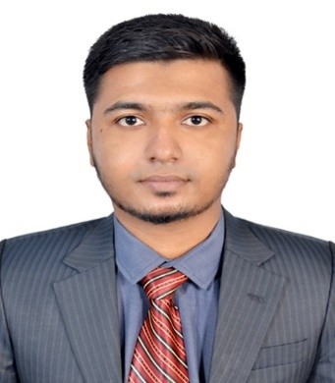

**Career Objective:**

To build up a career in a prominent organization where skills and commitment are best judged and help in achieving its organizational goal as well as to develop my organizational efficiency.

**Personal Information:**

|  |  |
| --- | --- |
| Full Name | : Nooren Zabran Ami |
| Father’s Name | : Khondokar Jamal Uddin |
| Mother’s Name | : Sabina Yeasmin |
| Date of Birth | : 26 August, 2000 |
| Nationality | : Bangladeshi |
| Home Town | : Khulna |
| Religion | : Islam (Sunni) |
| Marital Status | : Single |
| Blood Group | : O+ ve |
| Permanent Address | : 167/7 (Ga), Kashem Nagar-3, Gollamari,  Khulna-9100 |

**Technical Skills:**

* **Programming Languages:** C, C++, C#, JAVA
* **Operating System:** Linux OS, Windows 10
* **Database:** MySQL, Oracle, SQL Server
* **Networking Tools:** Cisco Packet Tracer
* **Other:** MS Word, MS PowerPoint, MS Excel, AutoCAD, Internet Browsing, E-mailing.

**Educational Qualification:**

* **Bachelor of Science in Computer Science and Engineering (CSE)**

Result: CGPA 3.44 (Out of 4.00) [Till 10th Semester]

Passing Year: 2022

***American International University-Bangladesh (AIUB)***

* **Higher Secondary School Certificate (HSC)**

Result: GPA 5.00 (Out of 5.00)

Group: Science

Passing Year: 2017

***Govt. M. M. City College, Khulna***

* **Secondary School Certificate (SSC)**

Result: GPA 5.00 (Out of 5.00)

Group: Science

Passing Year: 2015

***SOS Hermann Gmeiner School, Khulna***

**Academic Project:**

* Prepared a project entitled with **“Ride Sharing Company Management System”** using Oracle.
* Prepared a project entitled with **“Student Result Calculation System”** using JAVA.
* Developed a partial project entitled with **“AIUB Parking Management System”** using C#.
* Prepared software engineering model in a software development entitled with **“AIUB Parking Management System”**
* Prepared graphics project entitled with **“Eid Carnival”** using Open GL.
* Prepared a project entitled with **“Digital Treatment System”** using a Project Management Tool- **Trello.**

**Soft Skills:**

* Good Communication Skills
* Punctual & Dedicating
* Ability to work under pressure
* Self-confident & a quick learner
* Teamwork

**Extra-Curricular Activities & Interests:**

* Member of AIUB Computer Club (ACC)
* Organizer of CS FEST, Gaming FEST per year (2019, 2020) of my own university.
* Personal Interest: Travelling, Eating and Hang-out with friends.

**References Available on Request:**

**Prof. Dr. Dip Nandi**

Professor & Director, Faculty of Science & Technology,

*American International University-Bangladesh (AIUB)*

**E-mail:** [dip.nandi@aiub.edu](mailto:dip.nandi@aiub.edu)

**MD. Mehedi Hassan Onik**

Lecturer, Faculty of Science & Technology,

*American International University-Bangladesh (AIUB)*

Mobile No: 01719-612177

E-mail: [mehedi.onik@aiub.edu](mailto:mehedi.onik@aiub.edu)